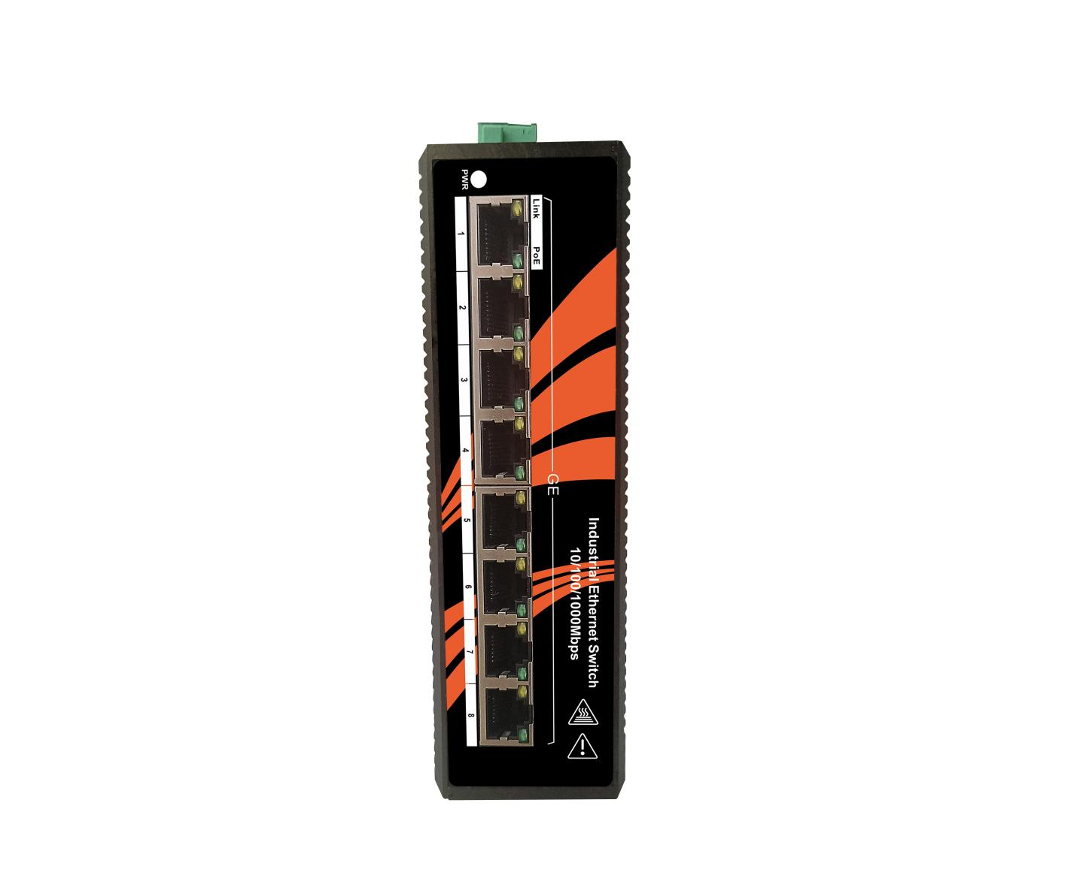**FEATURES**

## Supports 5 10/100/1000Base-T(X) electrical ports compliant with IEEE 802.3af/at PoE standard

## Each PoE port can provide up to 15.4W/25.4W 48VDC power output

## Automatic identification of power consumption and power supply mode of network equipment

## Electrical interface (RJ45 interface) supports 10/100/1000M self-adaptation, full/half duplex mode, MDI/MDI-X automatic detection

## Support full-duplex and half-duplex auto-negotiation.

## Comply with IEEE802.3/802.3U/802.3x store and forward mode.

## Dual power DC9~48V redundant input.

## Wide temperature working range -40℃~+85℃.

## Industrial grade design, no fan, no cooling hole.

## High-strength corrugated profile housing, rail mounting, IP40 protection level

Newbridge® The ND2PG05TX PoE unmanaged industrial Ethernet switch is specially designed for harsh and harsh industrial environments. It is equipped with 5 10/100/1000Base-T(X) Ethernet copper ports with PoE function. Each PoE electrical port can provide a maximum of 25.4W power supply for PoE terminals conforming to the IEEE 802.3af/at standard while transmitting Ethernet data, which is especially suitable for application scenarios where it is difficult to provide AC power and the cost of wiring is high.

As a Power over Ethernet Equipment (PSE), it supports 5 fully IEEE 802.3af/at compliant PoE and Ethernet composite ports, each PoE port can provide up to 15.4W/25.4W of 48VDC power output. Power supply for PoE IP cameras and wireless APs through network cables, eliminating the trouble of installing power supplies and power cables separately, and providing you with an economical and efficient industrial Ethernet communication solution.

ND2PG05TX PoE industrial Ethernet switch adopts industrial grade design: operating temperature range -40℃~+85℃, provides redundant dual power input, meets EMC industry level 4 requirements, IP40 protection level, aluminum chassis heat dissipation surface design, no fan, no Vents, rail or wall mount, certified for hazardous environments and FCC, CE compliant. It meets the reliability and practicability requirements of the industrial site for the network system. Its robust hardware design is ideal for industrial communication applications that require continuous operation.

Specifications

|  |  |  |
| --- | --- | --- |
| Product Name | | 5 Port 10/100/1000M Umanagement industrial grade PoE switch |
| Product Model | | ND2PG05TX |
| Interface | | 5x 10/100/1000Base-T ports（ PoE） |
| Network Protocols | | IEEE802.3 10BASE-T; IEEE802.3i 10Base-T;IEEE802.3u;100Base-TX/FX; IEEE802.3ab 1000Base-T;  IEEE802.3z 1000Base-X; IEEE802.3x;IEEE802.3af, IEEE802.3at；  IEEE 802.3x Flow Control， |
| PoE Specification | | PoE Standard: IEEE802.3af/ IEEE802.3at |
| PoE ports: 1-8 ports support PoE |
| Power Output:  Max. 15.4 watts (IEEE 802.3af)  Max. 30 watts (IEEE 802.3at) |
| PoE port Auto detect AF/AT devices |
| Output Voltage: DC48-57V |
| Power Pin Assignment:1/2+;3/6- |
| Power Type: End-span( Mid-span optional) |
| Network Media | | 10BASE-T: Cat3,4,5 UTP(≤100 meter)  100BASE-TX: Cat5 or later UTP(≤100 meter)  1000BASE-TX: Cat6 or later UTP(≤100 meter) |
| Performance Specification | | Bandwidth: 10Gbps  Packet Buffer Memory:1Mbits  10 Mbps Packet Forwarding Rate：14880 pps/port  100Mbps Packet Forwarfding Rate:148800 pps/port  1000Mbps Packet Forwarding Rate:1488000pps/port  MAC Address Table: 4K  Switching Delay: <10us |
| Forwarding Mode | | Store-and-Forward |
| Protection | | 6KV Lightening protection, IP40 protection |
| LED Indicators | | Power: PWR; Link; PoE; Link/Act |
| Power Supply | | Input Power: 48~57VDC (Terminal Block)  Input Power:2* 48~57VDC(Dual power redundancy backup)  Working Consumption : <8W  Connectors : Phoenix terminal  Overload protection :20A  Reverse polarity protection : 120s  Alarm contact : No |
| Working Environment | Working temperature: -40～+85℃ ;  Storage temperature: -40～+85℃  Relative Humidity: 5%~95 %( no condensation) | |
| Industry Standard | EMI: FCC Part 15 Subpart B Class A, EN 55022 Class A  EMS : IEC(EN)61000-4-2(ESD) : ±8kV contact discharge, ±15kV air discharge  IEC(EN)61000-4-3(RS) : 10V/m(80～1000MHz)  IEC(EN)61000-4-4(EFT): Power line: ±4kV; Data line: ±2kV  IEC(EN)61000-4-5(Surge): Power line: ±2kVCM/±4kVDM; Data line: ±4kV  IEC(EN)61000-4-6 (radio frequency conduction): 3V(10kHz～150kHz), 10V(150kHz～80MHz) IEC(EN)61000-4-16(Common mode conduction) : 30V cont. 300V,1s  Shock: IEC 60068-2-27 Freefall: IEC 60068-2-32 Vibration: IEC 60068-2-6 | |
| Shell | IP40 protect grade, metal shell | |
| Installation | DIN-Rail or Wall mounts | |
| Packing List | 1×Industrial PoE Switch (plus terminal block)  1×User Manual/Certificate of quality/Warranty card  1×DIN-Rail mounting kit | |
| Certification | CE mark, commercial;  FCC Part 15 Class B;  EN 55022 (CISPR 22), Class B | |
| MTBF | 300,000 hours | |
| Weight & Size | Product Weight: 0.9 KG  Product size (L×W×H): 145mm× 100mm× 45mm | |
| Warranty | 5-years | |

Order Information

|  |  |  |
| --- | --- | --- |
| **Part No** | **Description of product** | **Unit** |
| ND2PG05TX | 5*10/100/1000M Base-Tx Umanaged PoE Switch ,Industrial , aluminum alloy, DIN Rail, DC48~57V power supply ,Wide temperature (-40°C-85°C),CE-FCC-RoHs - DC power supply is not included by default. | pc |