**FEATURES**

* 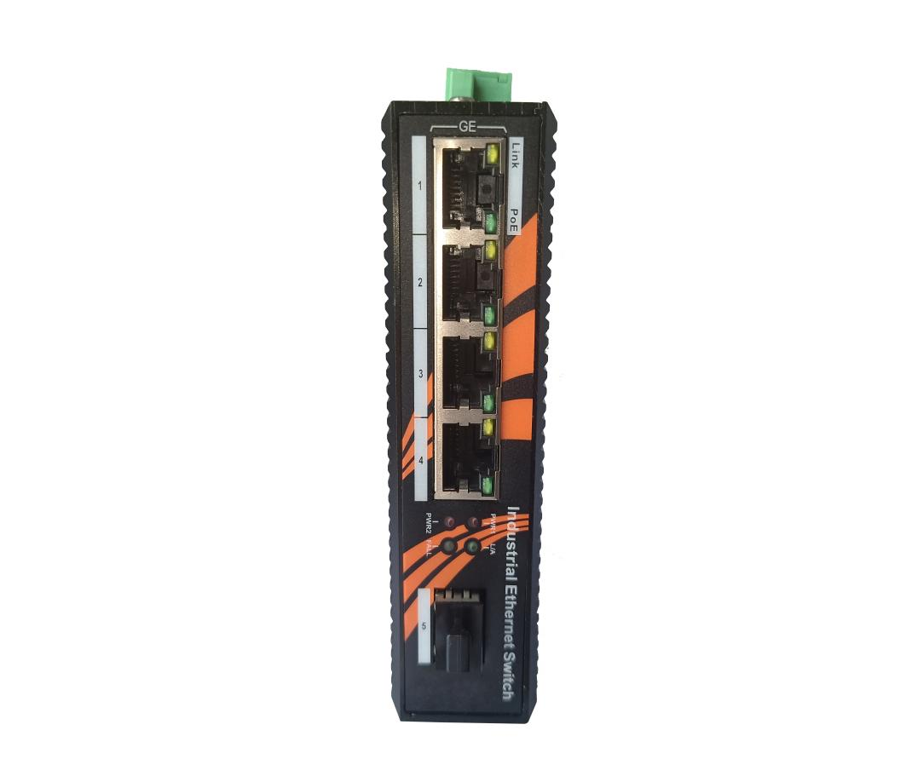4 10/100/1000Base-T(X) electrical ports conforming to IEEE 802.3af/at PoE standard, and 1 1000Base-SX/LX/LH/ZX optical port.
* Support full-duplex and half-duplex auto-negotiation.
* Comply with IEEE802.3/802.3U/802.3x store and forward mode.
* The electrical port supports IEEE802.3at/af standard PoE power supply function
* Wide temperature working range -40℃~+85℃.
* Industrial grade design, no fan, no cooling hole.
* IP40 enclosure protection grade,
* Meets industrial level 4 electromagnetic compatibility requirements
* Redundant dual power input
* Rail or wall mount

Newbridge® The ND2PG-1FX4TX PoE unmanaged industrial Ethernet switch is specially designed for harsh and harsh industrial environments, and can implement four 10/100/1000Base-T(X) (with PoE function) Conversion between signal and 1 1000Base-SX/LX/LH/ZX optical signal, as Power over Ethernet Equipment (PSE), supports 4 fully IEEE 802.3af/at compliant PoE and Ethernet composite ports, each PoE The port can provide up to 15.4W/25.4W of 48V DC power output. Power supply for PoE network IP cameras and wireless APs through network cables, and realize the access requirements of multiple end users through one optical fiber. It extends the distance of network transmission from the limit of 100 meters of copper wire to 120 kilometers. The optical interface supports transmission distances of 550m (multi-mode), 20km, 40km, 80km, 120km (single-mode), and supports three optical fiber transmission modes: dual-fiber multi-mode, dual-fiber single-mode, and single-fiber single-mode, expanding the user’s Requirements; the electrical interface supports 10/100/1000M self-adaptation, full/half duplex mode, MDI/MDI-X automatic detection. It is very convenient to use and operate, and supports functions such as Port VLAN, priority, and broadcast storm control. At the same time, one 1000Mbps optical port expands the network radius.

ND2PG-1FX4TX PoE industrial Ethernet switch adopts industrial grade design: -40℃~ +85℃ working temperature and redundant dual power input, IP40 protection level, meets EMC industry level 4 requirements, rail type or wall-mounted installation .

Specifications

|  |  |  |
| --- | --- | --- |
| Product Name | | 4 Port 10/100/1000M+1*1000Mbps SFP Slot Umanagement industrial PoE switch |
| Product Model | | ND2PG-1FX4TX |
| Interface | | 4x10/100/1000Base-T PoE port + 1x 1000Mbps SFP Slot |
| Network Protocols | | IEEE802.3 10BASE-T; IEEE802.3i 10Base-T;IEEE802.3u;100Base-TX/FX; IEEE802.3ab 1000Base-T;  IEEE802.3z 1000Base-X; IEEE802.3x;IEEE802.3af, IEEE802.3at；  IEEE 802.3x Flow Control |
| PoE Specification | | PoE Standard: IEEE802.3af/ IEEE802.3at |
| PoE ports: 1-4 ports support PoE |
| Power Output:  Max. 15.4 watts (IEEE 802.3af)  Max. 30 watts (IEEE 802.3at) |
| PoE port Auto detect AF/AT devices |
| Output Voltage: DC48-57V |
| Power Pin Assignment:1/2+;3/6- |
| Power Type: End-span( Mid-span optional) |
| Network Media | | 10BASE-T: Cat3,4,5 UTP(≤100 meter)  100BASE-TX: Cat5 or later UTP(≤100 meter)  1000BASE-TX: Cat6 or later UTP(≤100 meter) |
| Fiber Media | | Multi-mode: 2KM  Single-mode: 20/40/60/80KM  Interface:SC/SFP |
| Performance Specification | | Bandwidth: 10Gbps  Packet Buffer Memory:1Mbits  10 Mbps Packet Forwarding Rate：14880 pps/port  100Mbps Packet Forwarfding Rate:148800 pps/port  1000Mbps Packet Forwarfding Rate:1488000 pps/port  MAC Address Table: 2K  Switching Delay: <10us |
| Forwarding Mode | | Store-and-Forward |
| Protection | | 6KV Lightening protection, IP40 protection |
| LED Indicators | | Power: PWR; Link; PoE; Link/Act |
| Power Supply | | Input Power: 48~57VDC (Terminal Block)  Input Power:2* 48~57VDC(Dual power redundancy backup)  Working Consumption : <8W  Connectors : Phoenix terminal  Overload protection :20A  Reverse polarity protection : 120s  Alarm contact : No |
| Working Environment | Working temperature: -40～+85℃ ;  Storage temperature: -40～+85℃  Relative Humidity: 5%~95 %( no condensation) | |
| Industry Standard | EMI: FCC Part 15 Subpart B Class A, EN 55022 Class A  EMS : IEC(EN)61000-4-2(ESD) : ±8kV contact discharge, ±15kV air discharge  IEC(EN)61000-4-3(RS) : 10V/m(80～1000MHz)  IEC(EN)61000-4-4(EFT): Power line: ±4kV; Data line: ±2kV  IEC(EN)61000-4-5(Surge): Power line: ±2kVCM/±4kVDM; Data line: ±4kV  IEC(EN)61000-4-6 (radio frequency conduction): 3V(10kHz～150kHz), 10V(150kHz～80MHz) IEC(EN)61000-4-16(Common mode conduction) : 30V cont. 300V,1s  Shock: IEC 60068-2-27 Freefall: IEC 60068-2-32 Vibration: IEC 60068-2-6 | |
| Shell | IP40 protect grade, metal shell | |
| Installation | DIN-Rail or Wall mounts | |
| Packing List | 1×Industrial PoE Switch (plus terminal block)  1×User Manual/Certificate of quality/Warranty card  1×DIN-Rail mounting kit | |
| Certification | CE mark, commercial;  FCC Part 15 Class B;  EN 55022 (CISPR 22), Class B | |
| MTBF | 300,000 hours | |
| Weight & Size | Product Weight: 0.9 KG  Product size (L×W×H): 120mm×85mm× 28mm | |
| Warranty | 5-years | |

Order Information

|  |  |  |
| --- | --- | --- |
| **Part No** | **Description of product** | **Unit** |
| ND2PG-1FX4TX | 4*10/100/1000 Base-Tx Non-managed PoE Fiber Switch,1* SFP slot ,Industrial , aluminum alloy, DIN Rail, DC48~57V power supply ,Wide temperature (-40°C-85°C),CE-FCC-RoHS - DC power supply is not included by default. | pc |