**FEATURES**

* 10/100/1000Mbps Ethernet
* 10/100/1000 BASE-T/TX electrical port
* 1000 BASE-SX/LX optical port
* 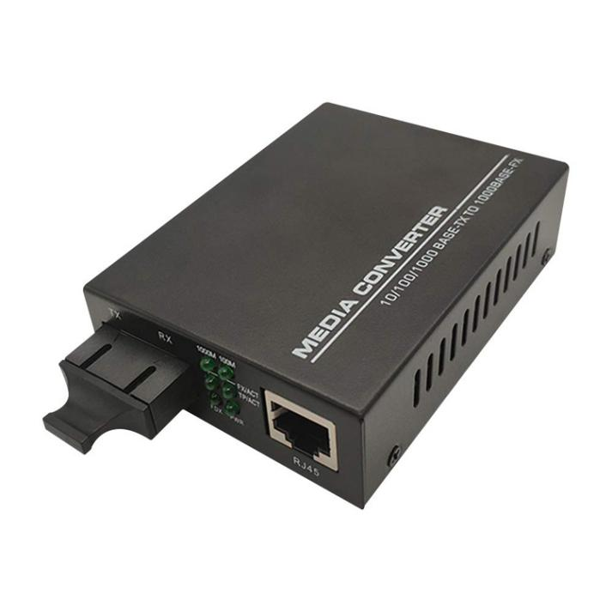Electrical port supports Auto-Negotiation for 10Mbps or 100Mbps or 1000Mbps , full duplex or half duplex data
* Optical port supports 1000Mbps full duplex data
* Automatic MDI/MDI-X crossover
* Distances up to 2km for Multi mode;Up to 120km for Single mode
* Voltage transient protection on all power and signal input.output lines provides unconditional protection from power surges and other voltage transient events
* No in-field optical adjustments required
* LED Indicators

**Newbridge**® Gigabit media converter with external power supply are designed to transmit and receive 10/100/1000Mbps data over optical fiber. The electrical interface will Auto-Negotiate to a 100Mbps or 1000Mbps Ethernet rate without any adjustments. The optical interface operates at a 1000Mbps Ethernet rate. Both are environmentally hardened to operate in extreme temperatures. LED indicators are provided for confirming equipment operating status.

16-Pot 10/100Mbps +2G TP/SFP Combo

PoE Switch with LCD Display

Specifications

|  |  |
| --- | --- |
| **Parameters** | **Specifications** |
| Standards | IEEE 802.3 10Base-T IEEE 802.3u 100Base-TX IEEE 802.3ab 1000Base-TX/FX |
| Transmission Distance | Multimode: 2km  Single mode:10km~120km |
| Port | One RJ45 port, Single fiber port (SC/ST/FC Optional) |
| MDI/MDI-X | Auto selection |
| Power Supply | External : 5V DC 1A/2A  Built-in: 90 V to 240 V AC 50Hz to 60 Hz  Power Consumption : ≤5W |
| Operating Temperature | 0 °C to +65 °C |
| Storage Temperature | -20 °C to +65 °C |
| Relative Humidity | 5% to 90% (non-condensing) |
| Dimensions | 95mm * 70 mm * 25mm |

Application Diagram

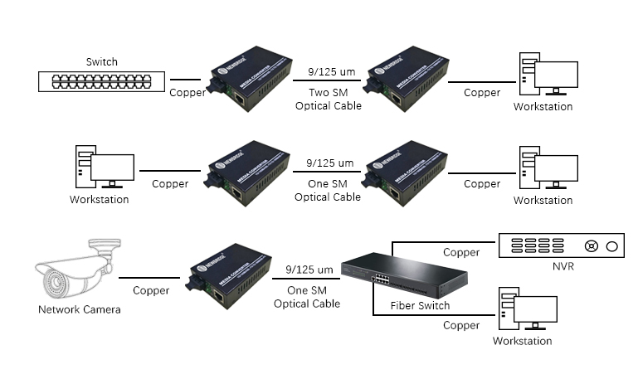



Order Information

|  |  |  |
| --- | --- | --- |
| **Part No** | **Description of product** | **Unit** |
| ND-921SW-20 | Dual fiber Single-mode ,20km，SC,220V/AC,5V2A/DC,1*1000Base-Fx+1*10/1000Base-Tx | pc |