**FEATURES**

## E:/赵的图片 资料/ai网站图片/产品图片/Media Converter/Industrial Media Converter/ND-X920-1FX2TX/2.png22 Port 10/100/1000MbpsEthernet port , 1 port 1000Mbps optical port.

## Automatic MAC address learning and aging

## 10/100/1000Mbps Auto-negotiation , auto-MDI-MDI-X

## LED indicators for monitoring power/link/activity

## Supports 10/100/1000Mbps-Full/Half-duplex

## Supports DIN-Rail installation

## Supports Daisy-Chain connection

## Supports Broadcast Storm Control

## Transmission data max. Support：1518 bytes

## Super lightening protection, IP40 protection

## Excellent heat elimination without cooling fan

## Redundant dual DC power inputs

## Apply to Urban Intelligent Traffic Monitoring System (ITS), Safe City

## Harsh industrial environment or higher requirement

## 6KV port Lightning protection

## -40℃~+85℃ operating temperature range

## Industrial grade design, no fan, no cooling hole.

## IP40 enclosure protection grade,

## Meets industrial level 4 electromagnetic compatibility requirements

Newbridge®ND-X920-1FX2TX Industrial Ethernet Switches uses store-forward architecture, fanless and energy-saving design. The advantage of product are small, convenient and easy to maintain. The product design complies with the Ethernet standard, adding lightning protection, anti-static protection measures. It applies to the wide range of operating temperature from -40℃ ~ +85℃ with stable and reliable performance. The device can be widely applied to various broadband data transmission fields such as intelligent transportation, telecommunications, security, financial securities, customs, shipping, power, water conservancy and oil fields.

Specifications

|  |  |
| --- | --- |
| Product Name | 2 Port 10/100/1000Mbps Industrial Media Converter |
| Product Model | ND-X920-1FX2TX |
| Interface | 2x10/100/1000Base-T Ethernet port + 1x 1000Mbps Optical port |
| Network Protocols | IEEE802.3 10BASE-T; IEEE802.3i 10Base-T;IEEE802.3u;100Base-TX/FX; IEEE802.3ab 100Base-T; IEEE802.3z 100Base-X; IEEE802.3x; |
| Network Media | 10BASE-T: Cat3,4,5 UTP(≤100 meter)  100BASE-TX: Cat5 or later UTP(≤100 meter) |
| Fiber Media | Multi-mode: 2KM  Single-mode: 20/40/60/80KM  Interface:SC/SFP |
| Performance Specification | Bandwidth: 6Gbps  Packet Buffer Memory:1M  10 Mbps Packet Forwarding Rate：14880 pps/port  100Mbps Packet Forwarfding Rate:148800 pps/port  1000Mbps Packet Forwarfding Rate:1488000 pps/port  MAC Address Table: 8K  Forwarding Delay:<4us |
| Forwarding Mode | Store-and-Forward |
| Protection | 6KV Lightening protection, IP40 protection |
| LED Indicators | Power: PWR; Link; PoE; Link/Act |
| Power Supply | Input Power: 12~48VDC (Terminal Block)  Input Power:2* 12~48VDC(Dual power redundancy backup)  Working Consumption : <5W  Connectors : Phoenix terminal  Overload protection :20A  Reverse polarity protection : 30s  Alarm contact : No |

|  |  |
| --- | --- |
| **Other Specifications** | |
| Working Environment | Working temperature: -40～+85℃ ;  Storage temperature: -45～+85℃  Relative Humidity: 5%~95 %( no condensation) |
| Industry Standard | FCC CFR47 Part 15,EN55022/CISPR22,  Class A EMS:  IEC6100-4-2 (ESD): ±8kV (contact), ±15kV (air)  IEC6100-4-3 (RS): 10V/m (80MHz-2GHz)  IEC6100-4-4 (EFT): Power Port: ±4kV; Data Port: ±2kV  IEC6100-4-5 (Surge): Power Port: ±2kV/DM, ±4kV/CM; Data Port: ±2kV IEC6100-4-6 (CS): 3V (10kHz-150kHz); 10V (150kHz-80MHz)  IEC6100-4-16 (Common mode conduction): 30V (cont.), 300V (1s)  IEC (EN) 61000-4-8：support  IEC 60068-2-27(Shock):support  IEC 60068-2-32(Freefall):support  IEC 60068-2-6(Vibration）：support |
| Shell | IP40 protect grade, metal shell |
| Installation | DIN-Rail or Wall mounts |
| Packing List | 1×Industrial PoE Switch (plus terminal block)  1×User Manual/Certificate of quality/Warranty card  1×DIN-Rail mounting kit |
| Certification | CE mark, commercial;  FCC Part 15 Class B;  VCCI Class B  EN 55022 (CISPR 22), Class B |
| MTBF | 300,000 hours |
| Weight & Size | Product Weight: 0.36KG  Product size (L×W×H): 118mm× 86mm× 39mm |
| Warranty | 3-years |

Application

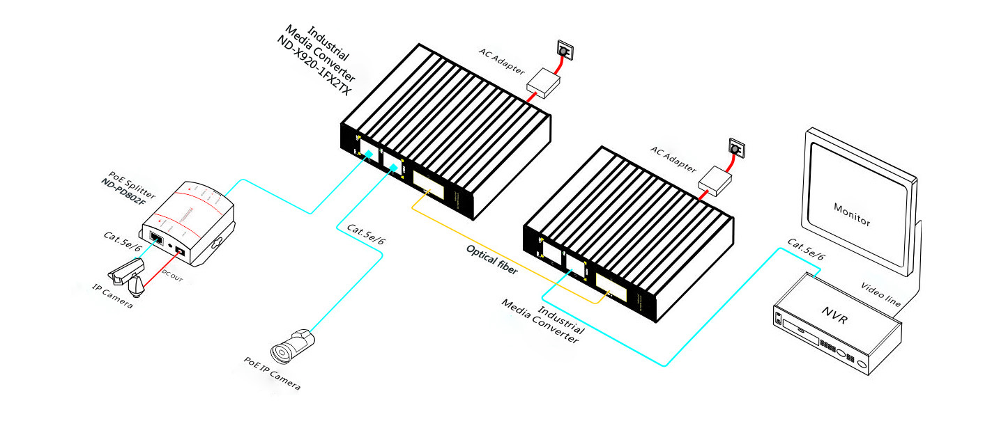

Order Information

|  |  |  |
| --- | --- | --- |
| **Part No** | **Description of product** | **Unit** |
| ND-X920-1FX2TX | 2*10/100/1000 Base-Tx Non-managed Fiber Switch,1*1000M SFP Slot ,Industrial , aluminum alloy, DIN Rail, DC12~48V power supply ,Wide temperature (-40°C-85°C),CE-FCC-RoHS - DC power supply is not included by default. | pc |