**FEATURES**

## Support IEEE 802.3/802.3u

## E:/赵的图片 资料/POE级联器/防水1进2出/2.png24*10/100Mbps auto-adaptive RJ45, support automatic flip (Auto-MDI/MDIX)

## Support 1K MAC address

## Support EEPROM configuration

## Support IEEE802.3 af/at

## All ports support 2KV lightning protection

## Support maximum forwarding packet length 2048 bytes

## With overload protection, output short circuit protection and other functions

## It has the characteristics of small size, high efficiency, stable operation, long-distance transmission, etc.

**Newbridge® ND-PE103W** is a standard waterproof outdoor POE repeater, consisting of 1 PD power receiving interface POE IN + 3 standard POE output interfaces POE OUT1 or POE OUT2 or POE OUT3, this is a high performance, low power consumption 10/100M trunk line extension transmission POE switch, which is the best choice for security monitoring, POE powered transmission networking and small intelligent construction. Provides 3*10/100Mbps ports and 1*10M/100Mbps POE PD power receiving interface, which can be used to connect higher bandwidth upstream devices. Supports standard POE input, port supports 52V output and 30W power. Uses store and forward technology to ensure bandwidth is allocated to each port efficiently. Full wire speed 100M rate connectivity to workgroups or servers, powerless design, plug and play, this flexible non-blocking architecture allows users to use networks that are not limited by bandwidth and media. The switch ports support half-duplex and full-duplex operating modes, each switch port supports adaptive features, and the ports use store-and-forward mode for network solutions.

Specifications

|  |  |
| --- | --- |
| Product Name | 4-port standard POE cascade treasure (POE repeater, POE extender) |
| Product Model | ND-PE103W |
| Interface | 1* 10/100M RJ45 POE OUT1（Auto Negotiation/Auto MDI/MDIX）  1* 10/100M RJ45 POE OUT2（Auto Negotiation/Auto MDI/MDIX）  1* 10/100M RJ45 POE OUT3（Auto Negotiation/Auto MDI/MDIX）  1*10/100M POE IN（PD reciprocating）（Auto Negotiation/Auto MDI/MDIX） |
| Standard/Protocol | IEEE 802.3u, IEEE 802.1Q,IEEE 802.1p,IEEE 802.3af/at |
| Network Media | 10BASE-T: Cat3,4,5 UTP(≤100 meter)  100BASE-TX: Cat5 or later UTP(≤100 meter) |
| Cascading | POE OUT1 or POE OUT2or POE OUT3 interface for cascading applications |
| Forwarding Mode | Store-and-Forward |
| Performance Specification | Bandwidth:0.8Gbps  Packet Buffer Memory:768kbits  packet forwarding rate:0.447MPPS  MAC Address Table: 1K  jumbo frame:2018bytes |
| LED Indicators | Power: PWR; Link; PoE; Link/Act |
| PoE Specification | PoE Standard: IEEE802.3af/ IEEE802.3at |
| Power Output:  Max. 15.4 watts (IEEE 802.3af)  Max. 30 watts (IEEE 802.3at) |
| PoE port Auto detect AF/AT devices |
| Output Voltage: DC48-57V |
| Power supply pin:1/2 (+) 3/6 (-) or 4/5 (+) 7/8 (-), input and output ports support 4-pin/8-pin power supply |
| Power Type: End-span( Mid-span optional) |
| Static power:<0.2W |
| Use environment | Working temperature: -10 ℃~ 70 ℃ (32℉~127℉)  Storage temperature: -40 ℃~85 ℃ (-97℉~142℉)  Working humidity: 10%~90%  non-condensing Storage humidity: 5%~95% non-condensing |
| Shell | plastic shell |
| Warranty | 1-years |

Application

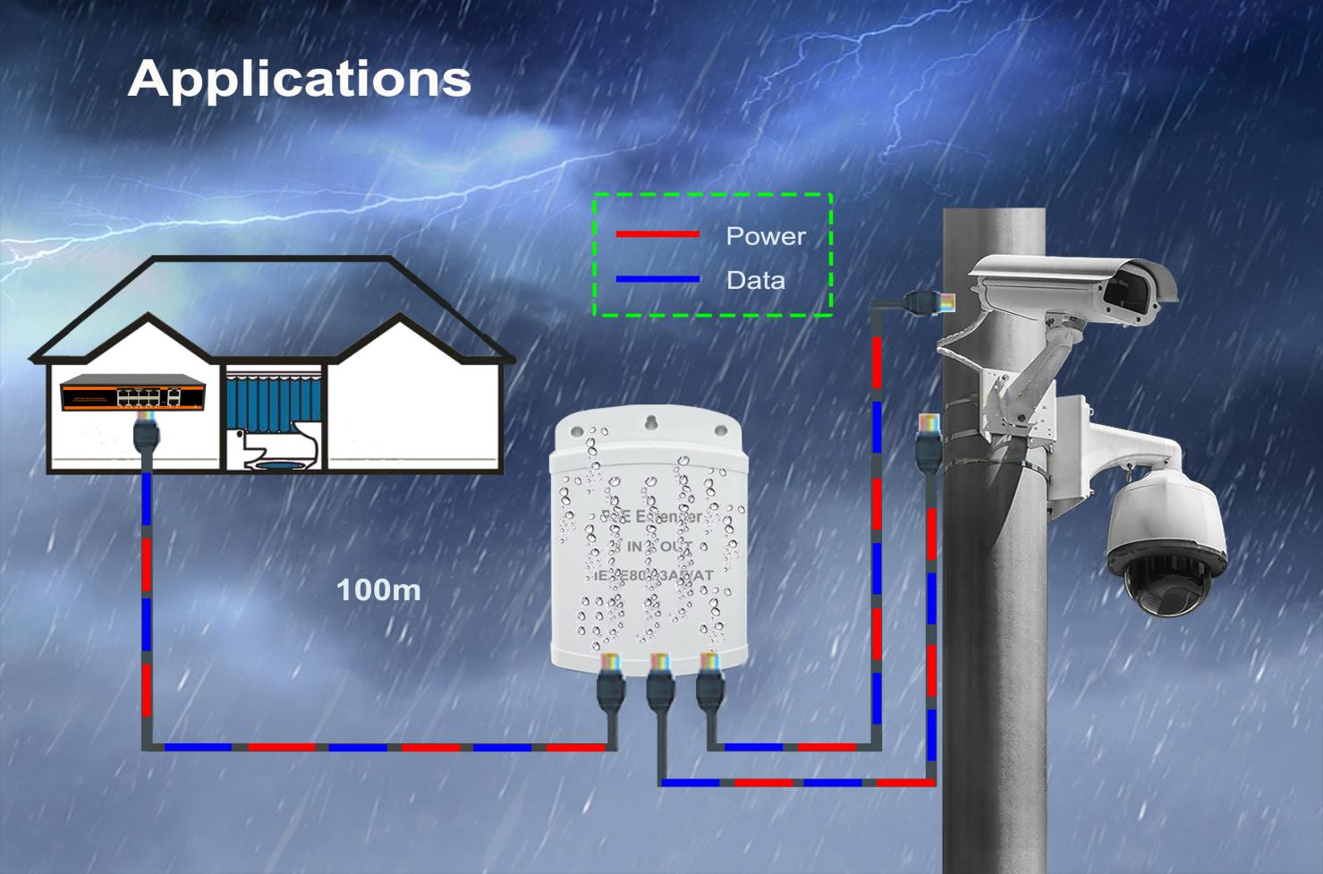

Order Information

|  |  |  |
| --- | --- | --- |
| **Part No** | **Description of product** | **Unit** |
| ND-PE103W | 4-port standard POE cascade treasure,  1* 10/100M RJ45 POE OUT1（Auto Negotiation/Auto MDI/MDIX）  1* 10/100M RJ45 POE OUT2（Auto Negotiation/Auto MDI/MDIX）  1* 10/100M RJ45 POE OUT3（Auto Negotiation/Auto MDI/MDIX）  1*10/100M POE IN（PD reciprocating）（Auto Negotiation/Auto MDI/MDIX） | pc |