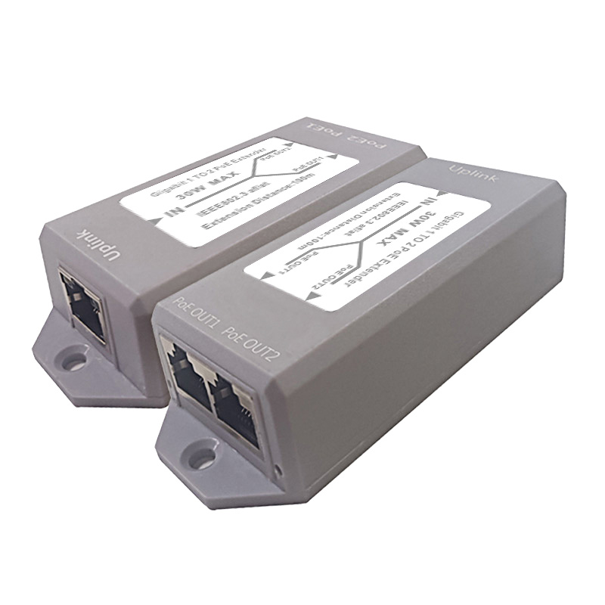**FEATURES**

## Support IEEE 802.3/802.3u

## 3*10/100/1000Mbps auto-adaptive RJ45, support automatic flip (Auto-MDI/MDIX)

## Support 1K MAC address

## Support EEPROM configuration

## Support IEEE802.3 af/at

## All ports support 2KV lightning protection

## Support 16 VLANs (IEEE Std 802.1q)

## Support maximum forwarding packet length 2048 bytes

## With overload protection, output short circuit protection and other functions

## It has the characteristics of small size, high efficiency, stable operation, long-distance transmission, etc.

**Newbridge® ND-PE102G** 1 PD power receiving interface POE IN + 2 standard POE output interfaces POE OUT1 or POE OUT2, national standard intelligent POE cascade treasure, also known as POE repeater, POE extender and other names; this is a high-performance, low-power The 10/100/1000M trunk line extension transmission POE switch with high power consumption is the best choice for security monitoring, POE power supply transmission networking, and small-scale intelligent construction. Provides 2*10/100/1000Mbps ports and 1*10M/100/1000Mbps POE PD power receiving interface, which can be used to connect upstream devices with higher bandwidth. Support standard POE input, port supports 52V output, 30W power. Store and forward technology is used to ensure that bandwidth is effectively allocated to each port. The full line-speed 1000M rate is connected to the workgroup or server, no power supply design, easy to plug and play, this flexible non-blocking structure, users can use without the limitation of bandwidth and media network. The switching port supports half-duplex and full-duplex working modes, each switching port supports adaptive function, and the port adopts the store-and-forward mode. networking solutions.

Specifications

|  |  |
| --- | --- |
| Product Name | 3-port standard POE cascade treasure (POE repeater, POE extender) |
| Product Model | ND-PE102G |
| Interface | 1* 10/100/1000M RJ45 POE OUT1（Auto Negotiation/Auto MDI/MDIX）  1* 10/100/1000M RJ45 POE OUT2（Auto Negotiation/Auto MDI/MDIX）  1*10/100/1000M POE IN（PD reciprocating）（Auto Negotiation/Auto MDI/MDIX） |
| Standard/Protocol | IEEE 802.3u, IEEE 802.1Q,IEEE 802.1p,IEEE 802.3af/at |
| Network Media | 10BASE-T: Cat3,4,5 UTP(≤100 meter)  100BASE-TX: Cat5 or later UTP(≤100 meter)  1000BASE-TX: Cat5 or later UTP(≤100 meter) |
| Cascading | POE OUT1 or POE OUT2 interface for cascading applications |
| Forwarding Mode | Store-and-Forward |
| Performance Specification | Bandwidth:6Gbps  Packet Buffer Memory:768kbits  packet forwarding rate:0.447MPPS  MAC Address Table: 1K  jumbo frame:2018bytes |
| LED Indicators | Power: PWR; Link; PoE; Link/Act |
| PoE Specification | PoE Standard: IEEE802.3af/ IEEE802.3at |
| Power Output:  Max. 15.4 watts (IEEE 802.3af)  Max. 30 watts (IEEE 802.3at) |
| PoE port Auto detect AF/AT devices |
| Output Voltage: DC48-57V |
| Power supply pin:1/2 (+) 3/6 (-) or 4/5 (+) 7/8 (-), input and output ports support 4-pin/8-pin power supply |
| Power Type: End-span( Mid-span optional) |
| Static power:<0.2W |
| Use environment | Working temperature: -10 ℃~ 70 ℃ (32℉~127℉)  Storage temperature: -40 ℃~85 ℃ (-97℉~142℉)  Working humidity: 10%~90%  non-condensing Storage humidity: 5%~95% non-condensing |
| Shell | plastic shell |
| Warranty | 1-years |

Application

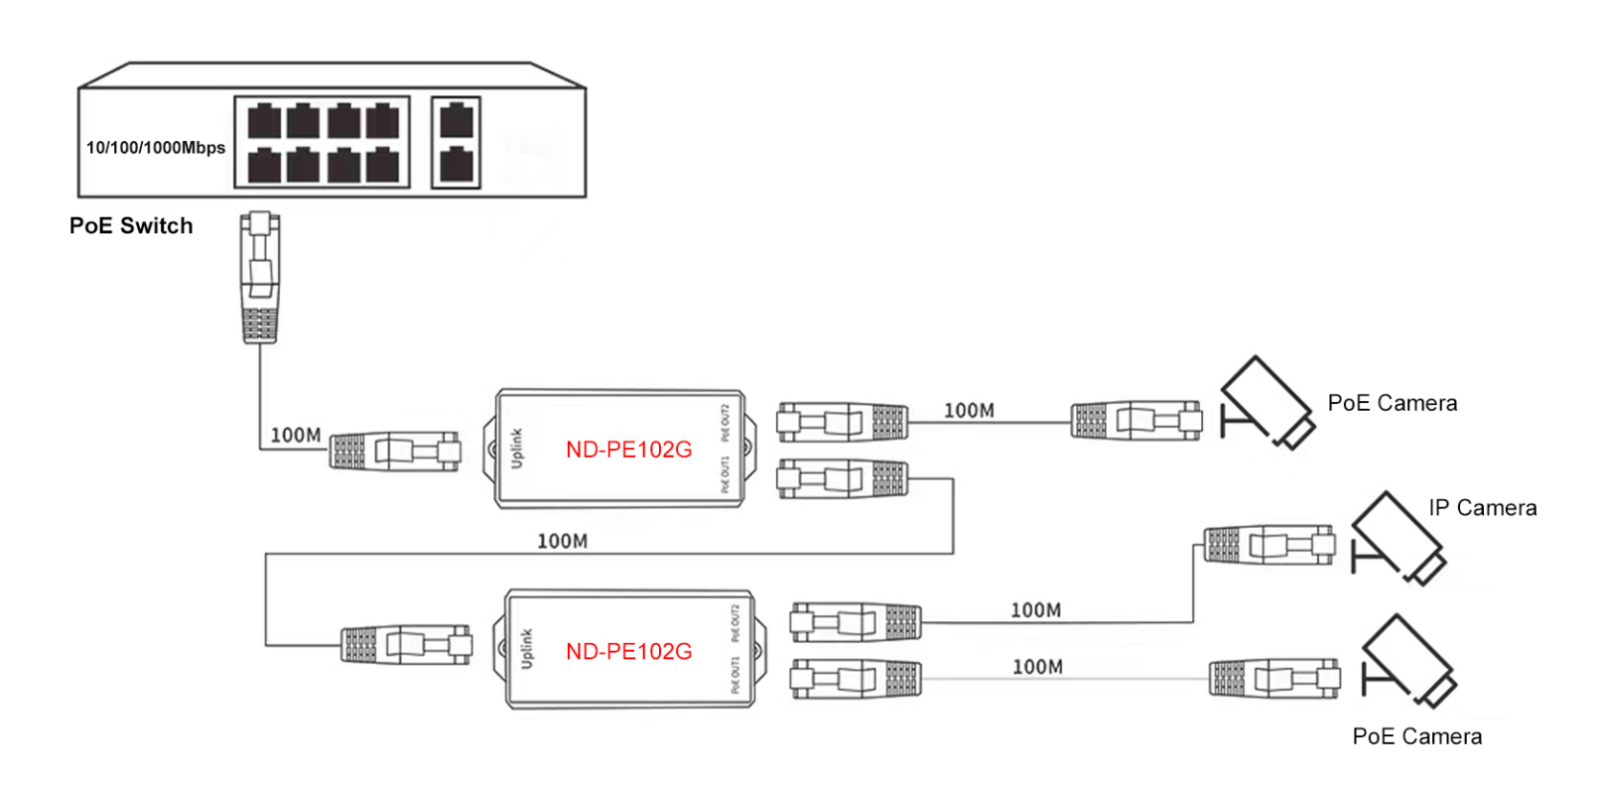-

Order Information

|  |  |  |
| --- | --- | --- |
| **Part No** | **Description of product** | **Unit** |
| ND-PE102G | 3-port standard POE cascade treasure,  1* 10/100/1000M RJ45 POE OUT1（Auto Negotiation/Auto MDI/MDIX）  1* 10/100/1000M RJ45 POE OUT2（Auto Negotiation/Auto MDI/MDIX）  1*10/100/1000M POE IN（PD reciprocating）（Auto Negotiation/Auto MDI/MDIX） | pc |