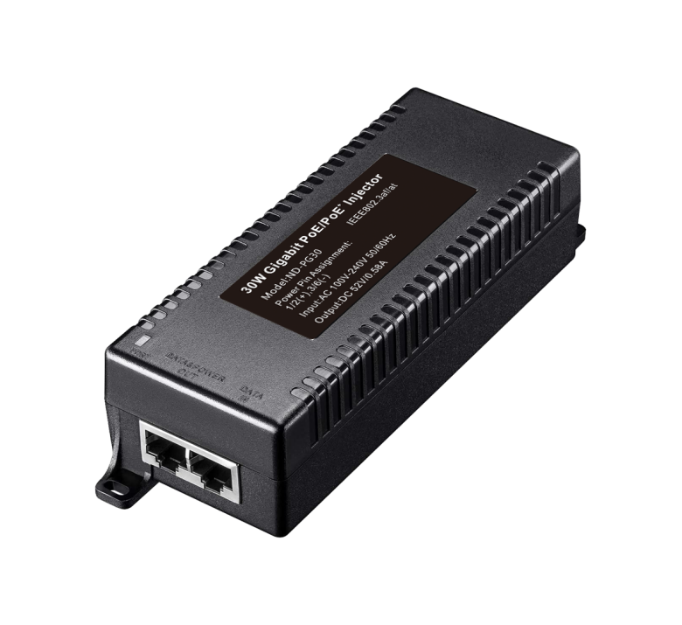**FEATURES**

## Support IEEE802.3AF/AT standard power supply protocol

## Output power supports up to 30 watts

## 2 ports Gigabit RJ45, 1GE POE output + 1GE data input

## Support dome cameras, industrial wireless APs, etc.

## Fluid Control: Full Duplex: IEEE802.3x, Half Duplex: Back Pressure

## Auto MDI/MDIX

## Support port lightning protection

## store and forward

## All ports support wire-speed switching, jumbo frame transmission

## Plug and play, adaptive

**Newbridge®ND-PI30**  is a single-port PoE injector with one Ethernet port, one PoE output port, and one AC input power port. It supports end-span PoE and the output power consumption is up to 30W. It features:10/100M/1000Mbps network, 100m transmission distance, 6KV lightning protection, industrial-level chip, and patent alert. it's an excellent choice for power supply and network transmission on PTZ cameras, all-in-one PC, digital display system.

PoE injectors connect non-PoE switches to PoE-powered devices via a network cable to provide power and data transmission. By eliminating the need to install additional power supplies for powered devices, PoE injectors effectively enhance network flexibility and scalability at a lower cost and allow equipment installation regardless of positions and existing network architectures.

Specifications

|  |  |  |  |
| --- | --- | --- | --- |
| Product Name | 30W Gigabit POE Power Supply | | |
| Product Model | ND-PI30 | | |
| Interface | 1 Gigabit POE power port + 1 Gigabit Ethernet port | | |
| Network Media | 10BASE-T: Cat5 UTP(≤250 meter)  100BASE-TX: Cat5 or later UTP(≤200 meter)  1000BASE-TX:Cat5 or later UTP(≤200 meter) | | |
| PoE Specification | PoE Standard: IEEE802.3af/IEEE802.3at | | |
| Power Output:  Max. 15.4 watts (IEEE 802.3af)  Max. 30 watts (IEEE 802.3at) | | |
| Output Voltage: DC55V | | |
| Power supply pin:1/2 (+) 3/6 (-) or 4/5 (+) 7/8 (-) | | |
| Use environment | Working temperature: -10 ℃~ 40 ℃  Storage temperature: -40～+85℃  Relative Humidity: 5%~95 %( no condensation) | | |
| LED Indicators | Power | Power Indicator: Yellow | |
| PoE load indicator: green | |
| power supply | Input Voltage:110V-264V working frequency:50/60Hz | | |
| Protection | Surge | | PoE Power: 1kV(Differential Mode),  kV(Common Mode)1.2/50us，8/20us |
| Ethernet: 2kV(Differential Mode),  6kV(Common Mode)10/7000us |
| ESD | | 1a Contact Discharge Level 3 |
| 1b  Air Discharge Level 3 |
| Per: IEC61000-4-2 |
| Shell | IP40 protect grade, Plastic housing | | |
| MTBF | 100,000 hours | | |
| Weight & Size | Product Weight: 0.3 KG  Product size (L×W×H): 140mm× 55mm× 40mm | | |
| Warranty | 2-years | | |

Application

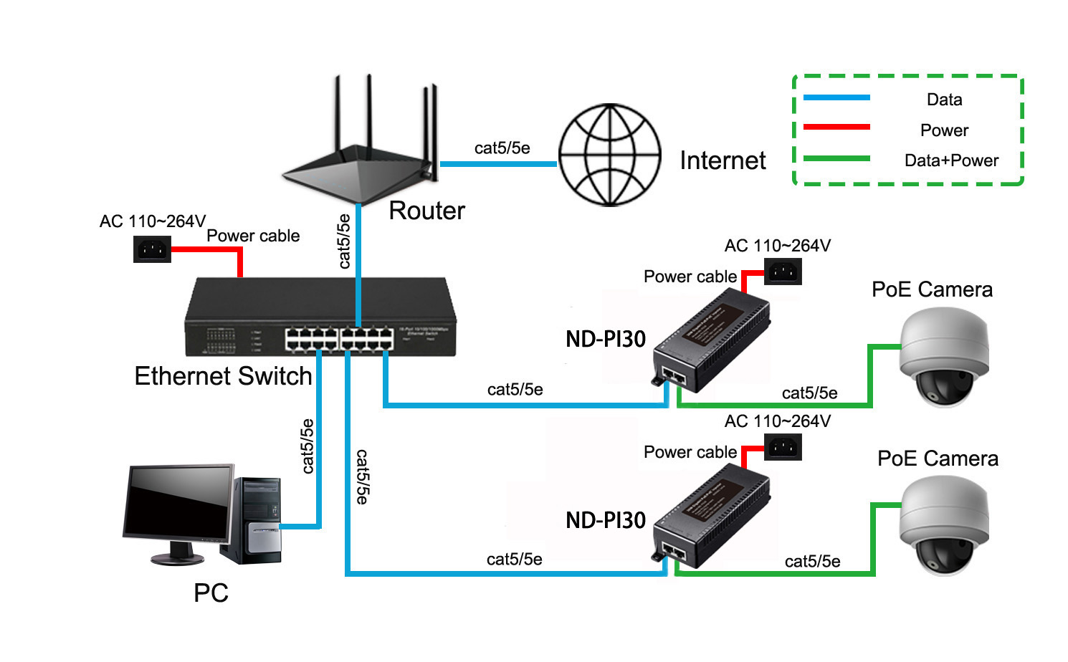

Order Information

|  |  |  |
| --- | --- | --- |
| **Part No** | **Description of product** | **Unit** |
| ND-PI30 | 10/100/1000M PoE injector 30W | pc |