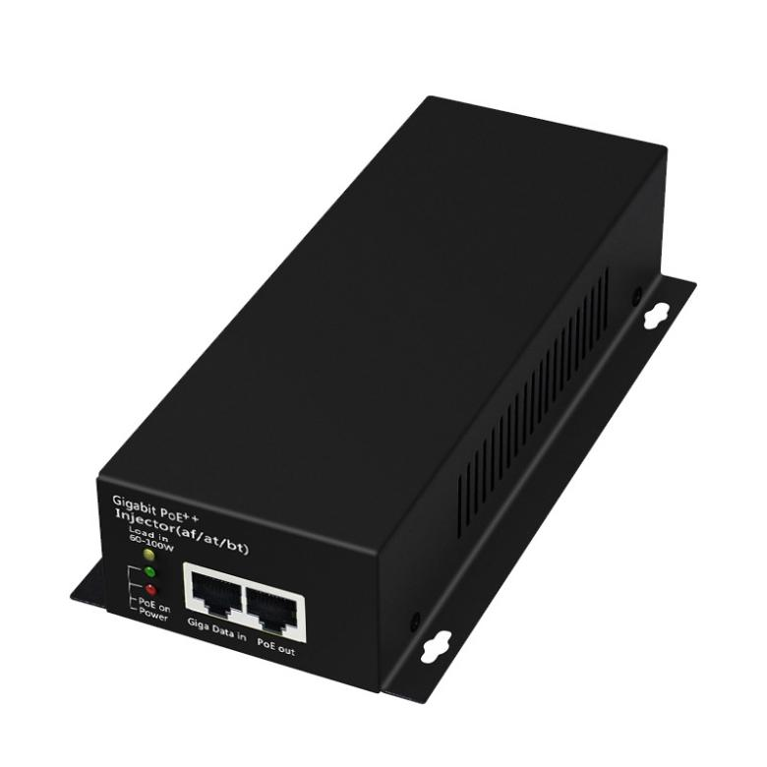**FEATURES**

## Support IEEE802.3BT standard power supply protocol

## Backward compatible with IEEE802.3AF/AT

## Output power supports up to 90 watts

## 2 ports Gigabit RJ45, 1GE POE output + 1GE data input

## Support dome cameras, industrial wireless APs, etc.

## Fluid Control: Full Duplex: IEEE802.3x, Half Duplex: Back Pressure

## Auto MDI/MDIX

## Support port lightning protection

## store and forward

## All ports support wire-speed switching, jumbo frame transmission

## Plug and play, adaptive

**Newbridge®** ND-PI90 is a single-port high-power PoE power supply device. The device is equipped with a common network input port, a PoE output port, and an AC power input port. The product is based on POE++ design and is compatible with the mid-end crossover method; the device can integrate ordinary network signals into PoE signal output, with a maximum output power of 90W, maximum support for 10/100/1000M networks, transmission distance up to 100m, common mode 4KV, differential Modular 2KV lightning protection and surge protection, effectively improve the anti-interference ability of the product, meet the wide temperature requirements of -10 ° C ~ 40 ° C, the product is widely used in power supply and network transmission of high-speed dome cameras, 11ac wireless AP, lighting, digital signage display systems and other equipment .

Specifications

|  |  |  |
| --- | --- | --- |
| Product Name | 90W Gigabit POE Power Supply | |
| Product Model | ND-PI90 | |
| Interface | 1 Gigabit POE power port + 1 Gigabit Ethernet port | |
| Network Media | 10BASE-T: Cat5 UTP(≤250 meter)  100BASE-TX: Cat5 or later UTP(≤200 meter)  1000BASE-TX:Cat5 or later UTP(≤200 meter) | |
| PoE Specification | PoE Standard: IEEE802.3af/IEEE802.3at/IEEE802.3bt | |
| Power Output:  Max. 15.4 watts (IEEE 802.3af)  Max. 30 watts (IEEE 802.3at)  Max. 90 watts (IEEE 802.3bt) | |
| Output Voltage: DC55V | |
| Power supply pin:1/2 (+) 3/6 (-) or 4/5 (+) 7/8 (-) | |
| Use environment | Working temperature: -10 ℃~ 40 ℃  Storage temperature: -40 ℃～+85℃  Relative Humidity: 5%~95 %( no condensation) | |
| LED Indicators | Power | Always bright:Device powered up |
| not bright:Device does not power on |
| POE power  30%60%90% | Always bright:current power state |
| not bright:Power usage below proportional value |
| power supply | Input Voltage:110V-264V working frequency:50/60Hz | |
| standard test | EMS : IEC(EN)61000-4-2(ESD) : ±8kV contact discharge, ±15kV air discharge  IEC(EN)61000-4-5(Surge): common mode 6KV, differential mode 1KV  IEC(EN)61000-4-3(RS) : 10V/m(80～1000MHz)  IEC(EN)61000-4-6(CS)  IEC(EN)61000-4-4(EFT): Power line: ±4kV; Data line: ±2kV  FCC Part15/CISPR32/EN55032;CLASS A  Shock: IEC 60068-2-27 Freefall: IEC 60068-2-32 Vibration: IEC 60068-2-6 | |
| Shell | IP20 protect grade, metal shell | |
| MTBF | 100,000 hours | |
| Weight & Size | Product Weight: 0.9 KG  Product size (L×W×H): 187mm× 95mm× 40mm | |
| Warranty | 2-years | |

Application

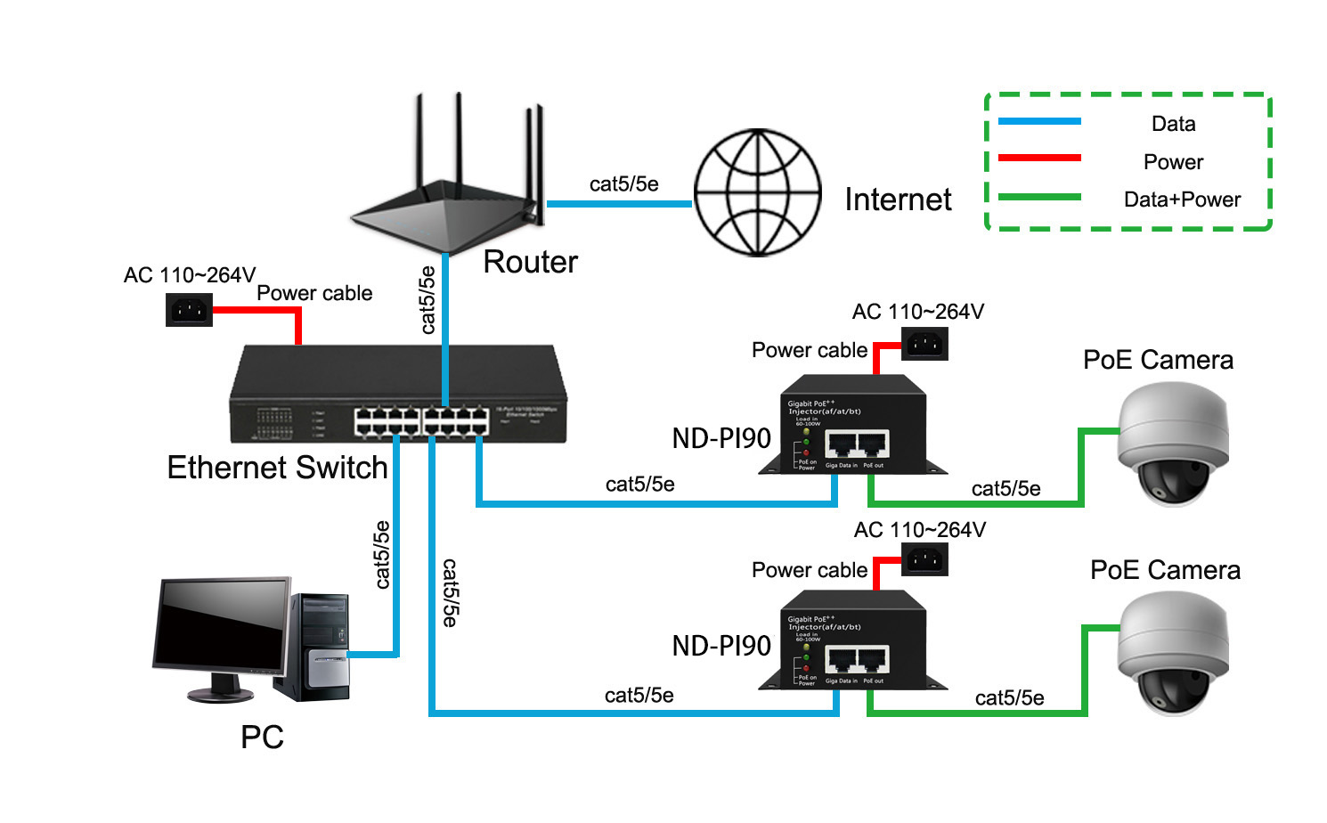

Order Information

|  |  |  |
| --- | --- | --- |
| **Part No** | **Description of product** | **Unit** |
| ND-PI90 | 10/100/1000M PoE injector 90W | pc |
| ND-PI60 | 10/100/1000M PoE injector 60W | pc |