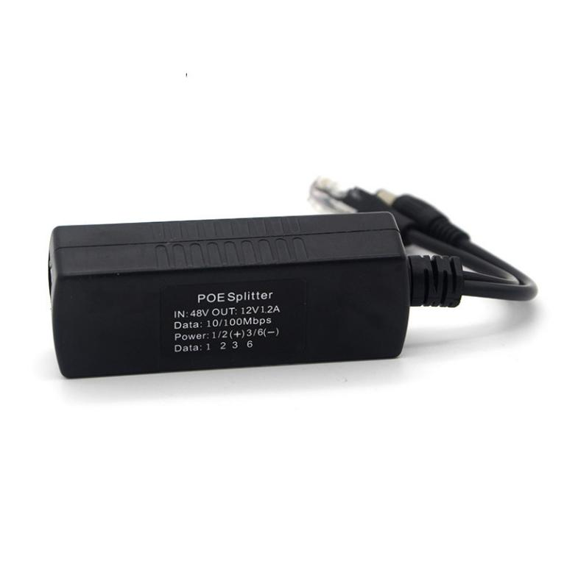**FEATURES**

## Support IEEE802.3 af

## Output power 15W

## Output voltage 12V

## The transmission bandwidth is 10/100M

## Signal network transformer isolation, more effective anti-interference and anti-surge function

## With automatic identification of powered, short-circuit automatic protection, over-current automatic disconnection and other functions

**Newbridge®**  ND-PS803 POE splitter is a PoE splitter carefully crafted by NEWBRIDGE. It conforms to the IEEE 802.3af standard and can provide DC 12V power supply for network terminals below 15W, with a transmission bandwidth of 10/100M.

The ND-PS803 POE splitter separates the power and data signals transmitted through the network cable, and is used with power supply equipment that conforms to the IEEE 802.3af standard (such as PoE power supply switches, PoE centralized power supplies, PoE power supply transceivers, etc.) Network devices that support PoE provide both data and power. The ND-PS803 splitter can output 12V voltage and can be used with power supply equipment to flexibly expand home network and office network without being restricted by the layout of power lines.

The ND-PS803 POE splitter has good compatibility, strong anti-interference ability, short-circuit overload protection and other good performance, compatible with all standard non-standard switches, It supports standard 1236 power supply and non-standard 45+ 78- power supply. The standard poe splitter can be used with standard 48V POE switches or non-standard 48V POE switches.

Specifications

|  |  |
| --- | --- |
| Product Name | POE splitter (non-isolation) |
| Product Model | ND-PS803 |
| PoE Standard | IEEE 802.3af |
| Network Media | 10BASE-T: Cat3,4,5 UTP(≤100 meter)  100BASE-TX: Cat5 or later UTP(≤100 meter) |
| PoE Specification | PoE Standard: IEEE802.3af |
| Power Output:  Max. 15.4 watts (IEEE 802.3af) |
| Input Voltage: 36V-57V |
| Output Voltage: DC12V |
| Power supply pin:1/2 (+) 3/6 (-) or 4/5 (+) 7/8 (-), input and output ports support 4-pin/8-pin power supply |
| Use environment | Working temperature: -10 ℃~ 60 ℃  Working humidity: 10%~90%  non-condensing Storage humidity: 5%~95% non-condensing |
| Dielectric strength | 1.0KVAC/1min |
| Insulation resistance | ≥500MΩ@500VDC |
| protect the circuit | surge, overheating, overcurrent |
| Electromagnetic Compatibility Standard EMC | EN55022 classB,EN55024,EN61000-3-2,3,EN61000-4-2,3,4,5,6,8,11 |

EMC

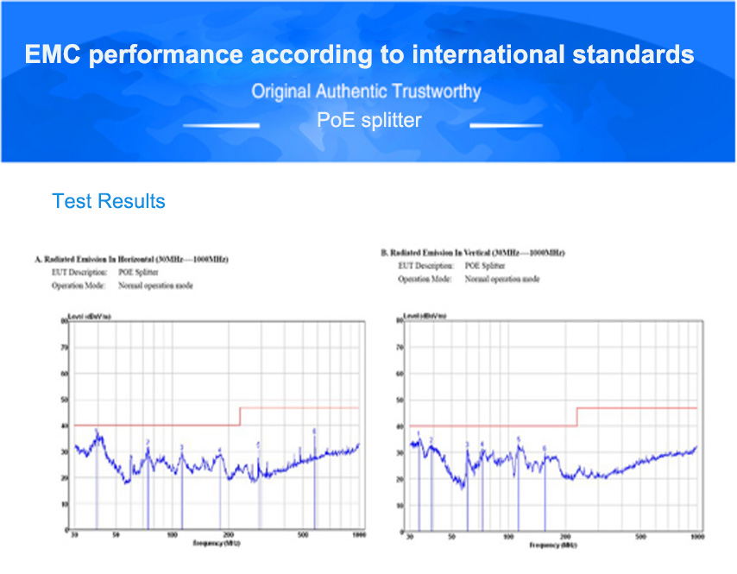

Application

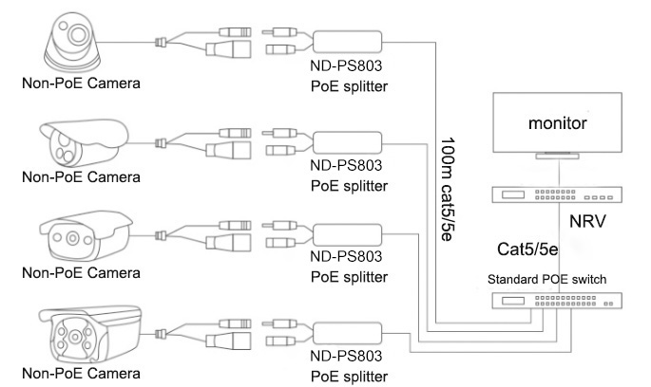-

Order Information

|  |  |  |
| --- | --- | --- |
| **Part No** | **Description of product** | **Unit** |
| ND-PS803 | 10/100M POE splitter 15W | pc |